MACHINE LEARNING REPORT
BUSINESS PROBLEM ANALYSIS USING PYTHON

Shubham Rakesh Syania

TABLE OF CONTENTS
Introduction
Objectives
Description of Variables
Data Manipulation
Outlier Detection and Visualization
Detailed Analysis of Colum
Data Exploration
K-Means Clustering (Model Building)
Cross-Cluster Trends and Business Insights
Broader Business Implications

Introduction
Overview
The dataset summarizes usage patterns for approximately 9,000 active credit card users over the past six months. It contains customer-level data across 18 behavioral attributes. The objective is to perform customer segmentation to inform and optimize marketing strategies.

Objectives
To perform customer profiling on credit card users using behavioral data, by applying K-Means clustering after structured data manipulation, visualization, and exploration, to identify meaningful customer segments that can support data-driven marketing strategies.

Description of Variables

- CUST_ID: Unique identifier assigned to each credit card holder
- BALANCE: Current outstanding balance available for purchases
- BALANCE_FREQUENCY: Frequency with which the balance is updated; ranges from 0 (rarely updated) to 1 (frequently updated)
- PURCHASES: Total value of purchases made using the credit card
- ONEOFF_PURCHASES: Highest single transaction value (one-time purchase)
- INSTALLMENTS_PURCHASES: Total value of purchases made through installments
- CASH_ADVANCE: Total amount of cash withdrawn in advance using the credit card
- PURCHASES_FREQUENCY: Frequency of purchases made; score ranges between 0 and 1
- ONEOFF_PURCHASES_FREQUENCY: Frequency of one-time (single) purchase transactions
- PURCHASES_INSTALLMENTS_FREQUENCY: Frequency of installment-based purchases
- CASH_ADVANCE_FREQUENCY: Frequency of cash advances taken
- CASH_ADVANCE_TRX: Total number of cash advance transactions
- PURCHASES_TRX: Total number of purchase transactions
- CREDIT_LIMIT: Maximum credit limit allocated to the user
- PAYMENTS: Total payments made by the user
- MINIMUM_PAYMENTS: Minimum amount paid toward the outstanding balance
- PRC_FULL_PAYMENT: Percentage of the balance paid in full by the user
- TENURE: Duration (in months) of the customer's relationship with the credit card issuer

Data Manipulation

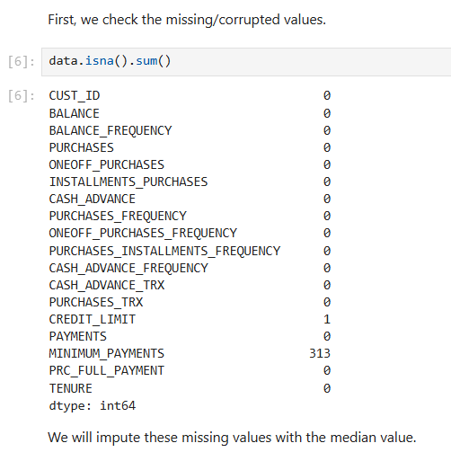

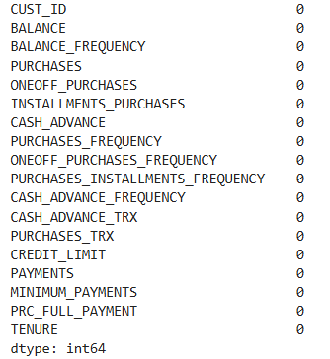

Dropping Cust_ID

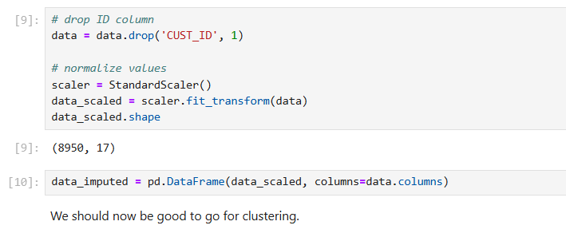

Outlier Detection and Visualization

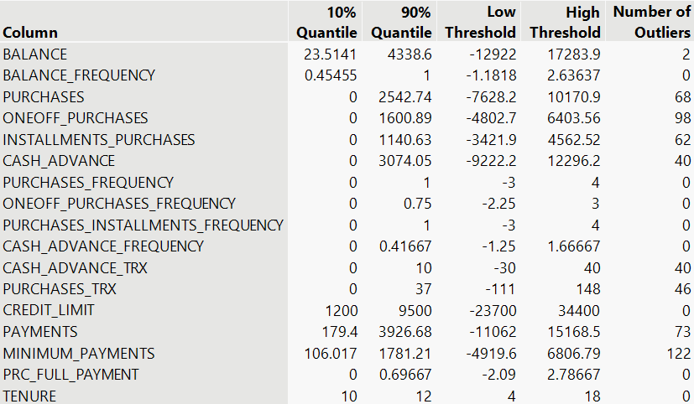

Based on the provided image of the JMP Pro outlier detection analysis, here's a more detailed analysis of the identified outliers for each column:

Detailed Analysis of Column

- BALANCE:
Two customers have exceptionally high balances.

- BALANCE_FREQUENCY:
No outliers; balance updates are consistent.

- PURCHASES:
Many customers made very high total purchases.

- ONEOFF_PURCHASES:
Several large one-time purchases were detected.

- INSTALLMENTS_PURCHASES:
Some customers have high installment purchase totals.

- CASH_ADVANCE:
Many took large cash advances, a potential risk indicator.

- PURCHASES_FREQUENCY:
One customer made no purchases (low outlier).

- ONEOFF_PURCHASES_FREQUENCY:
No outliers; frequency is consistent.

- PURCHASES_INSTALLMENTS_FREQUENCY:
No outliers found.

- CASH_ADVANCE_FREQUENCY:
Some customers took cash advances frequently.

- CASH_ADVANCE_TRX:
Many had a high numbers of cash advance transactions.

- PURCHASES_TRX:
Some customers shopped very frequently.

- CREDIT_LIMIT:
Both very low and very high limits were found.

- PAYMENTS:
Many made high payments, possibly due to high balances.

- MINIMUM_PAYMENTS:
High minimum payments are common, may reflect high balances or terms.

- PRC_FULL_PAYMENT:
Few consistently pay very little of the full balance.

- TENURE:
Some customers have very short or long credit card relationships.

Data Exploration
Correlation

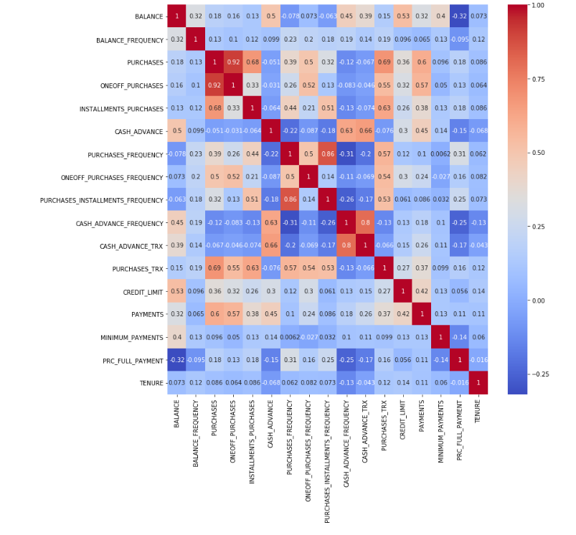

Strong Positive Correlations
PURCHASES & ONEOFF_PURCHASES (0.92):
Customers who make high purchases overall also tend to make large one-off purchases.

PURCHASES & PURCHASES_TRX (0.66):
Higher total purchases are linked with a higher number of purchase transactions.

CASH_ADVANCE & CASH_ADVANCE_TRX (0.8):
Customers who take large cash advances often do so more frequently.

PURCHASES_FREQUENCY & PURCHASES_INSTALLMENTS_FREQUENCY (0.86):
Customers who buy frequently also tend to use installment plans frequently.

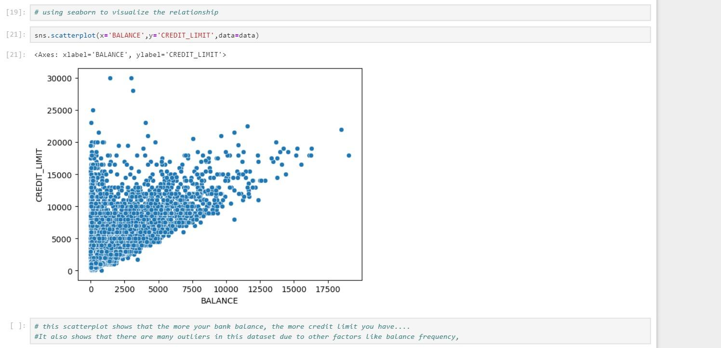

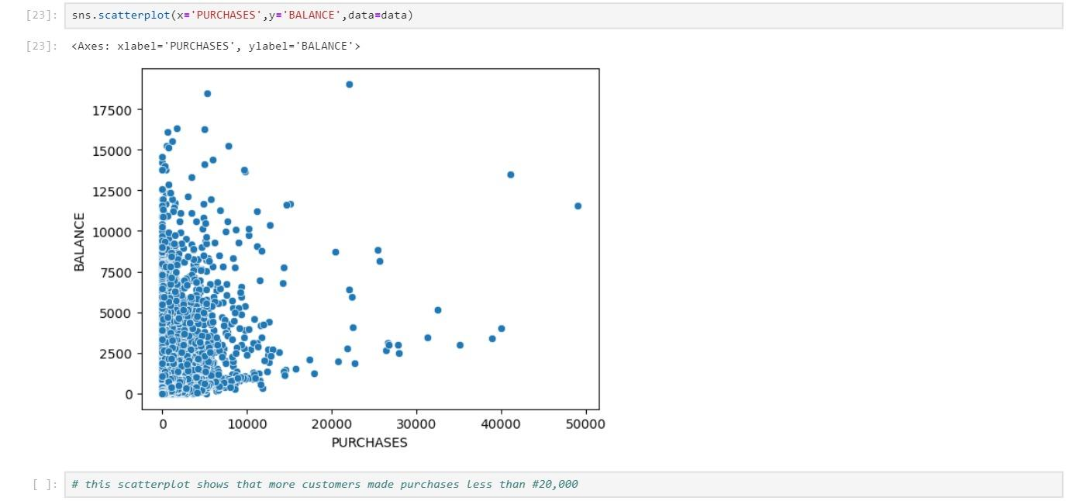

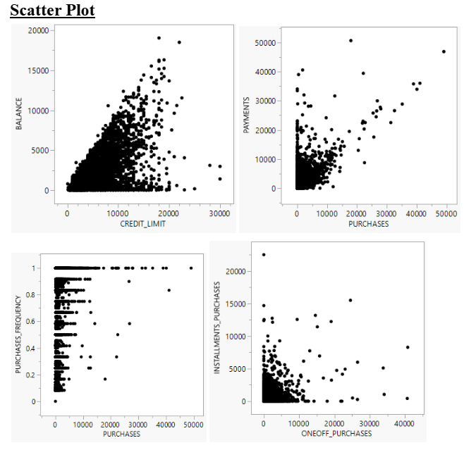

Insights
- Moderate positive correlation (0.53): See if higher limits lead to higher outstanding balances— adjust credit risk policies.
- Strong positive correlation (0.60): Understand if bigger spenders repay more or default. Shapes credit strategies.
- Positive correlation (0.57): Check if frequent buyers are high spenders or not — helps in loyalty program targeting.
- Very strong negative correlation (-0.64): Understand customer preference: one-time vs
installment shopping. Could tailor EMI.

NORMALISE VALUES
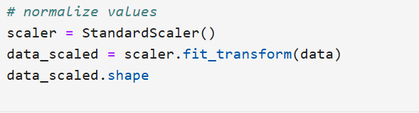
Before proceeding with clustering, all numerical variables were normalised using StandardScaler, which transformed the features to have zero mean and unit variance. This step ensured that no variable dominated the clustering process due to scale differences.

K-Means Clustering (Model Building)

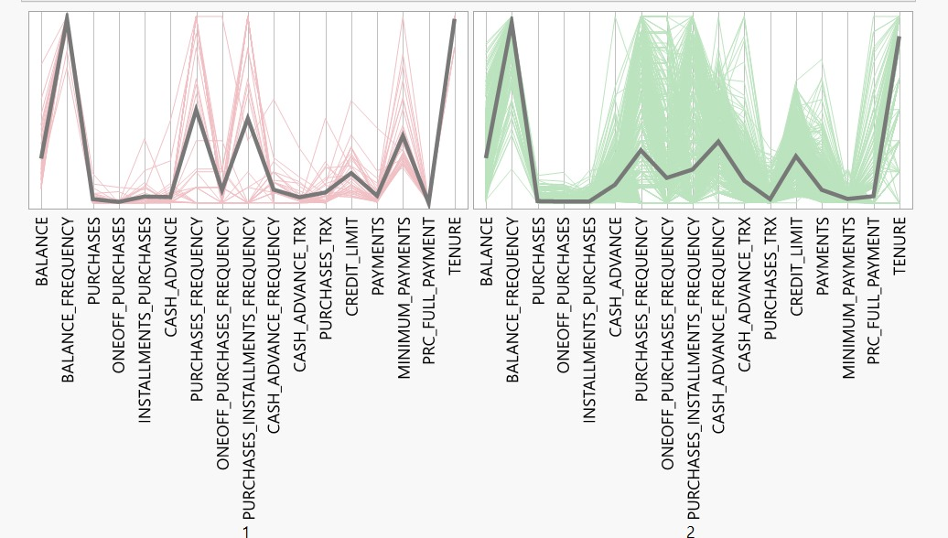
CLUSTER 1

High on BALANCE and BALANCE_FREQUENCY: These customers maintain high balances and frequently update them.

Low on ONEOFF_PURCHASES and INSTALLMENTS_PURCHASES: Not actively purchasing.

Low on PURCHASES, CASH_ADVANCE, and related frequencies: Overall inactive spending behavior.

Moderate CREDIT_LIMIT and PAYMENTS, low PRC_FULL_PAYMENT: They don’t fully pay off balances.

Insight: Likely credit hoarders or inactive users who hold cards but don't transact much. May present credit risk due to low full payments despite high balances.

CLUSTER 2

High TENURE: Loyal long-term users.

Moderate BALANCE and CREDIT_LIMIT.

Slight spikes in ONEOFF_PURCHASES and INSTALLMENTS_PURCHASES, but not frequent.

Relatively higher PRC_FULL_PAYMENT and PAYMENTS: They tend to repay responsibly.

Insight: These are stable and responsible customers, not very active but financially disciplined. Likely good targets for loyalty or upsell programs.

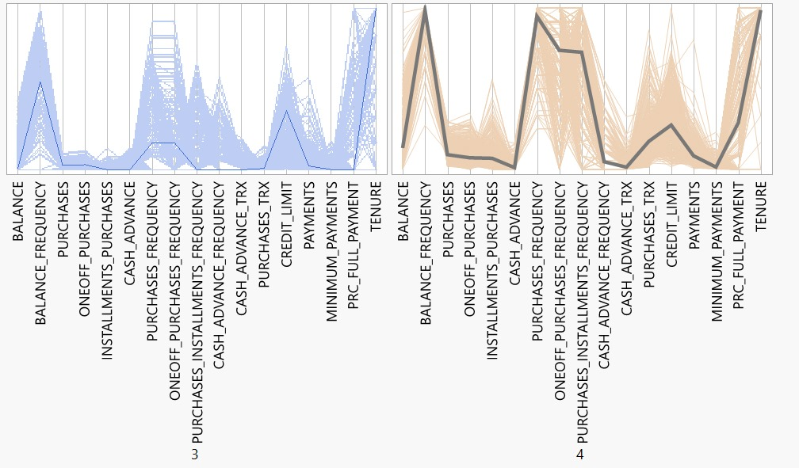
CLUSTER 3

Very high activity across PURCHASES, ONEOFF_PURCHASES, INSTALLMENTS_PURCHASES, PURCHASES_FREQUENCY: Very active spenders.

Low CASH_ADVANCE and CASHADVANCEFREQUENCY: They prefer purchases over cash withdrawals.

Moderate-to-high CREDIT_LIMIT, high PAYMENTS, and PRC_FULL_PAYMENT: Good repayment behavior.

Insight: These are ideal customers—active users, rarely withdraw cash, and pay in full. High value for banks due to transaction volume and low default risk. Perfect for rewards and cashback targeting.

CLUSTER 4

Moderate BALANCE but very low PRC_FULL_PAYMENT: Possibly revolving credit users.

Low PURCHASES but moderate CASH_ADVANCE and high CASHADVANCETRX: Use cards more for cash than for purchases.

TENURE is high: Long-term customers, but possibly in financial stress.

Low PAYMENTS and MINIMUM_PAYMENTS: Worrying trend for repayment behavior.

Insight: Likely risky users or cash-dependent customers. May need risk-based pricing, financial counseling, or limit control to manage credit exposure.

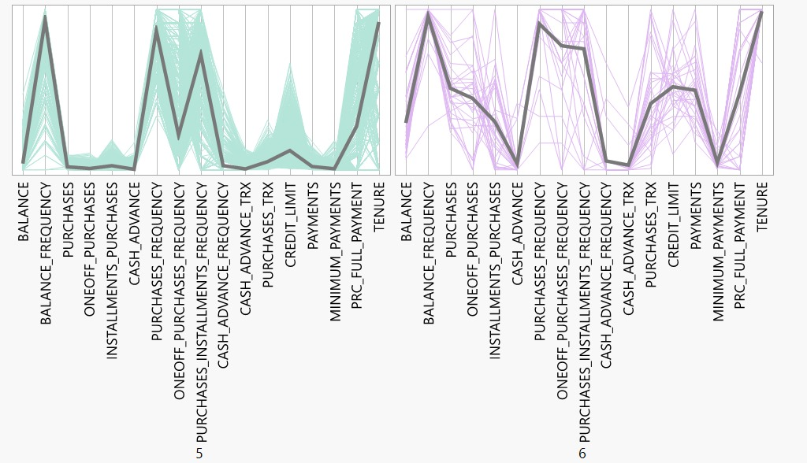

CLUSTER 5

Low BALANCE but high BALANCE_FREQUENCY: Users actively monitor but maintain a low balance.
Low PURCHASES and low PURCHASE_FREQUENCY: Minimal usage of credit card for purchases.
Very low CASH_ADVANCE and CASHADVANCE_FREQUENCY: Avoid using the card for cash withdrawals.
Low PAYMENTS, MINIMUM_PAYMENTS, and PRC_FULL_PAYMENT: Poor repayment behavior and possible revolving debt.
Moderate TENURE: Long-standing but inactive credit users.
Insight: Low engagement, low revenue, and potential repayment risk. Candidates for limit reduction, credit education, or downgrade to secured products.

CLUSTER 6

Moderate BALANCE with high BALANCE_FREQUENCY: Actively monitor and maintain balanced usage.
High PURCHASES and PURCHASE_FREQUENCY: Frequent use of card for purchases over cash.
Low CASH_ADVANCE and CASHADVANCE_FREQUENCY: Avoid cash withdrawals — positive risk indicator.
High PAYMENTS, MINIMUM_PAYMENTS, and PRC_FULL_PAYMENT: Strong repayment habits and financial discipline.
Moderate TENURE: Established and stable customer relationship.
Insight: Valuable and low-risk users. Ideal for loyalty programs, credit limit enhancements, or premium card upgrades.

Cross-Cluster Trends and Business Insights

1. Balance Behavior and Repayment Patterns

Clusters with high average balances and low proportion of full payments (e.g., Cluster 1) indicate reliance on revolving credit and elevated credit risk. In contrast, Clusters 2, 3, and 6 demonstrate moderate balances with high proportions of full payments, reflecting strong financial discipline and low default probability.

Strategic Insight: Full payment behavior is a reliable predictor of creditworthiness. Customers exhibiting this behavior should be prioritized for rewards programs, while low full-payment segments should be closely monitored for credit risk.

2. Cash Advance Usage and Financial Stress Indicators

Clusters with high frequencies of cash advance transactions, low full payment rates, and low payment volumes (e.g., Cluster 4) indicate short-term liquidity stress. Clusters 3 and 6 show low cash advance usage and strong repayment behavior, signifying financial stability and profitability.

Strategic Insight: Cash advance frequency acts as a proxy for financial stress. Consider implementing targeted interventions such as financial counseling or credit limit controls for high-usage segments.

3. Tenure and Customer Activity

Tenure does not consistently correlate with customer engagement. Cluster 2 consists of long-standing customers with moderate transaction activity and high repayment discipline, indicating loyalty but low engagement. Cluster 4 combines high tenure with low purchases and poor repayment, signaling disengagement and risk.

Strategic Insight: Tenure should be used in combination with usage and repayment metrics to enable more nuanced customer segmentation.

4. Purchase Patterns and Relationship Strength

Clusters 3 and 6 show a positive correlation between purchase frequency, payments, and full repayment, indicating a healthy financial cycle and responsible behavior. Clusters 1, 4, and 5 exhibit low purchasing activity and poor repayment or high cash advance usage, suggesting dormancy or financial distress.

Strategic Insight: High-frequency purchasing combined with repayment consistency indicates a strong relationship quality. These customers should be prioritized for loyalty programs and engagement campaigns.

5. Payment Behavior as a Risk Indicator

Across clusters, PAYMENTS, MINIMUM_PAYMENTS, and PRC_FULL_PAYMENT are consistent indicators of customer health. Clusters 3 and 6 display strong repayment behavior, while Clusters 1, 4, and 5 show subpar repayment, indicating heightened credit risk.

Strategic Insight: A payments behavior framework should underpin risk monitoring and support real-time decision-making in credit operations.

Broader Business Implications
● Segmented Customer Treatment:
The clustering exercise reveals clear stratification of credit card users based on financial discipline, usage patterns, and potential profitability. A risk-reward matrix can be constructed, wherein Clusters 3 and 6 represent low-risk, high-reward customers suited for loyalty enhancement, while Clusters 4 and 5 are high-risk, low-engagement users requiring risk containment strategies.
● Behavior-Based Personalization:
Rather than demographic or tenure-based targeting, behavioral clusters offer a dynamic path for personalized marketing and credit decisions. Programs like cashback offers, credit limit upgrades, or debt consolidation advisory can be tailored to the behavioral signature of each cluster.
● Early Risk Detection and Proactive Retention:
The cash advance dependency and low full payment behavior seen in Clusters 4 and 5 flag potential financial distress or credit fatigue. Proactive engagement through financial literacy tools, or even automated alerts for sudden changes in cash advance or payment habits, can reduce non-performing asset risk.
Strategic Interventions Based on Customer Clustering Insights

1. Dynamic Limit Management System (DLMS)
Context and Rationale:
Clusters such as 1, 4, and 5 exhibit credit hoarding or sustained revolving debt, increasing exposure to delinquency risk. Traditional static credit limits do not adapt to these behavioral variations.
Recommendation:
Implement a Dynamic Limit Management System that recalibrates individual credit limits monthly, based on repayment history, purchase behavior, and cash advance frequency. Customers showing risk-prone behavior can receive proactive alerts, with options like temporary credit freezes or structured repayment plans.
Expected Outcomes:
- Reduces default risk through controlled exposure
- Aligns credit allocation with customer behavior
- Enhances portfolio health and operational agility

2. Value-Based Cross-Selling Model
Context and Rationale:
Clusters 3 and 6 represent high-value, low-risk segments that remain underleveraged from a cross-sell perspective.
Recommendation:
Deploy a Value-Based Cross-Sell Engine that recommends suitable products—premium cards, linked savings, or BNPL schemes—based on behavior-driven segmentation. Offers should be personalized and aligned with the customer’s financial profile.
Expected Outcomes:
- Increases product penetration and fee income
- Enhances wallet share among profitable customers
- Strengthens loyalty via personalized offerings

3. Behavior-Triggered Credit Coaching Program
Context and Rationale:
Clusters 4 and 5 show signs of repayment irregularity and financial stress, with high cash advance usage and low payment volumes.
Recommendation:
Launch an AI-based Credit Wellness Coach embedded in the mobile app. The coach would detect behavior patterns such as persistent underpayment or rising cash advances and trigger timely nudges, financial tips, or alternative loan offers.
Expected Outcomes:
- Improves financial behavior and reduces delinquencies
- Builds trust through advisory engagement
- Transforms at-risk users into self-managed customers

4. Gamified Reward Ladder
Context and Rationale:
Clusters 1 and 2 exhibit low engagement and transactional activity, limiting revenue generation from fees and usage-based metrics.
Recommendation:
Introduce a Gamified Usage Ladder that allows customers to earn rewards, such as lower annual fees or bonus points, by completing simple behavioral goals (e.g., number of transactions, timely payments). Progress is tracked visibly within the app to enhance motivation.
Expected Outcomes:
- Stimulates usage in dormant or passive users
- Enhances engagement at minimal operational cost
- Reinforces desirable financial behavior

5. Cluster-Driven Lifecycle Management
Context and Rationale:
Static segmentation fails to reflect real-time shifts in customer behavior, reducing responsiveness across marketing and risk functions.
Recommendation:
Embed the clustering model into the CRM and risk infrastructure to create a dynamic, behavior-driven segmentation system. Clusters should be reviewed and updated regularly, with feedback loops from ongoing campaigns to refine targeting.
Expected Outcomes:
- Enables responsive, adaptive customer engagement
- Supports personalized credit and marketing strategies
- Enhances the long-term effectiveness of segmentation

